Bansilal Ramnath Agarwal Charitable Trust’s

Vishwakarma Institute of Technology, Pune-37
(An autonomous Institute of Savitribai Phule Pune University)


Department of Multidisciplinary Engineering

Division | AIML-A
Batch | 01
GR No. | 12414243
Roll No. | 08
Name | Abhishek Anil Patil

Title:
- Create single table read-only view
- Single table updatable view
- Multitable view
- View with aggregate function
- Insert, delete and update operations through view
- Create or replace view

Description: In this assignment, we implemented Views on the Workout Planner database using Exercises and Available_Equipments tables. We created read-only and updatable views, a multi-table join view, and a view with aggregate functions. We also performed insert, update, and delete operations through views and used CREATE OR REPLACE VIEW to modify existing ones. This showed how views simplify queries, enhance security, and present data clearly.

Screenshots/Output:

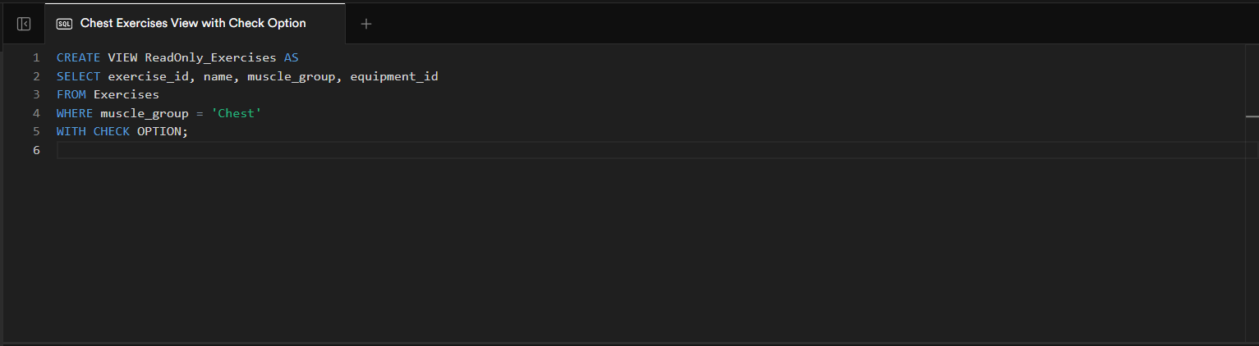
1)

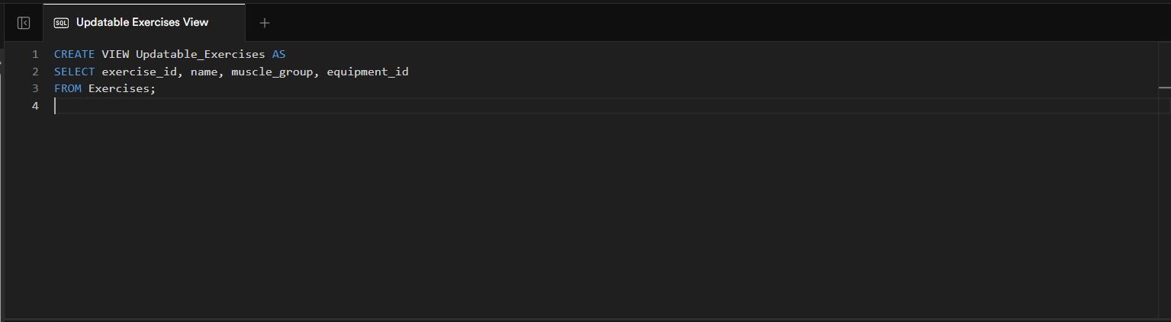
2)

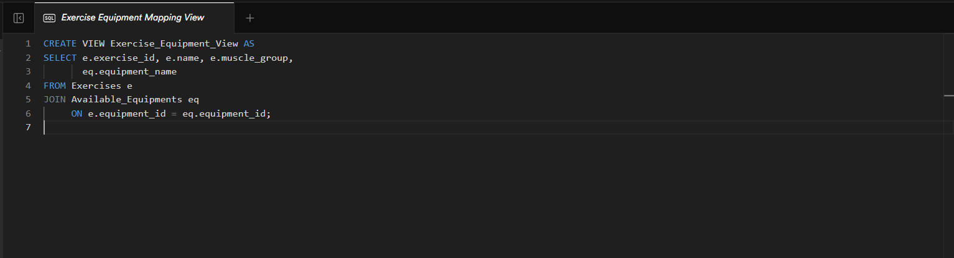
3)

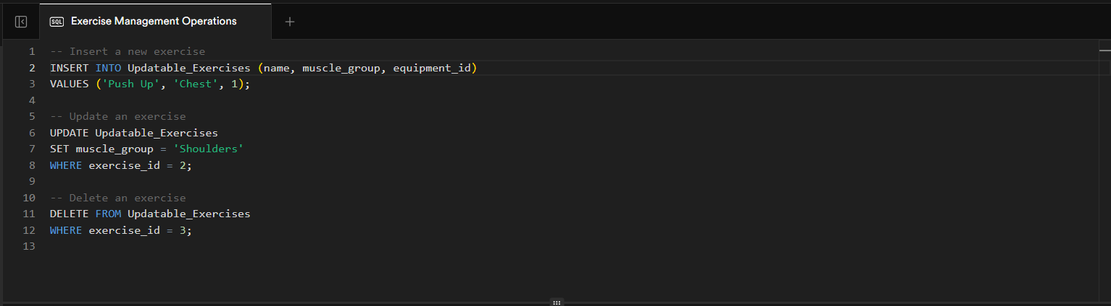
4)

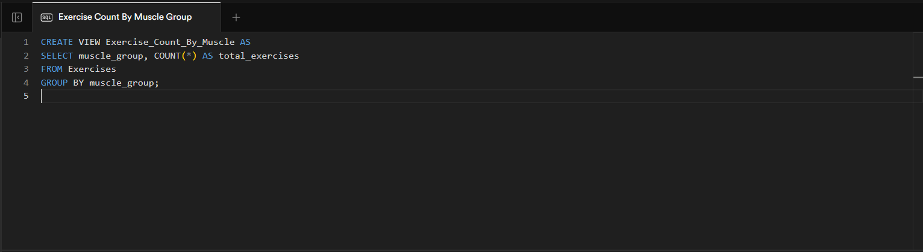
5)

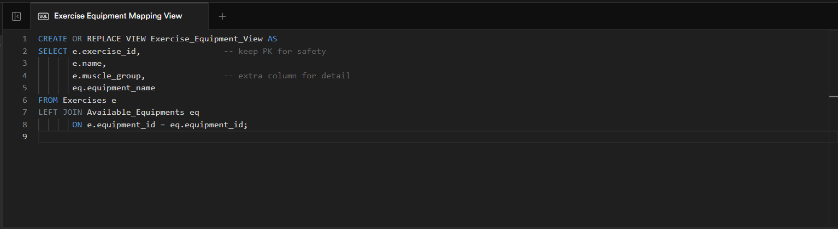
6)
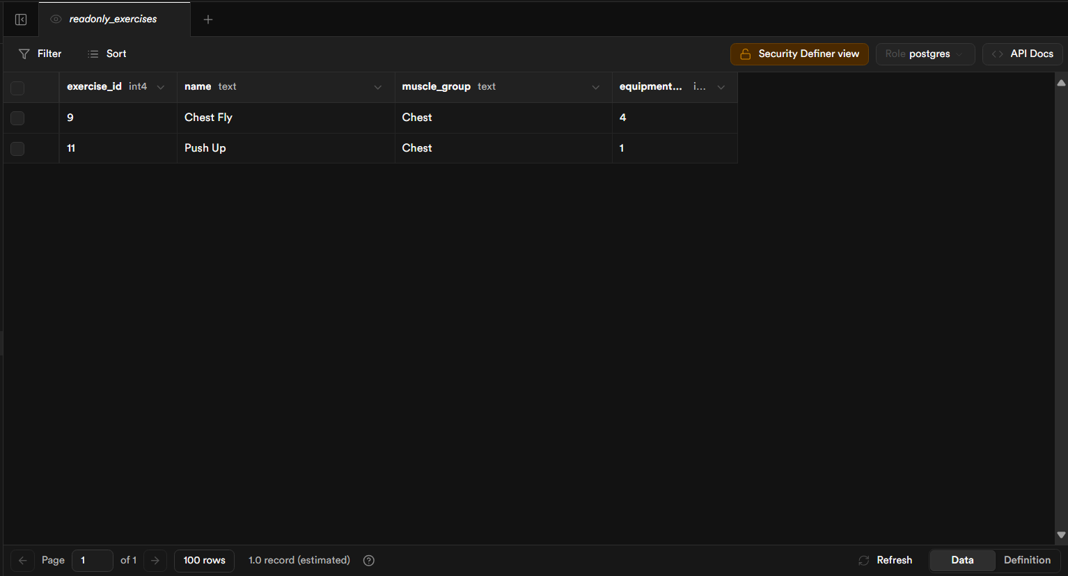
Outputs:

